

STUDENT CASE STUDY EXECUTION

Department | FED
Subject | DSA-2
Academic Year | I-III Semester (2025-26)
Faculty Name | Mamatha
Student Name | K.Siri Chandana
Roll Number | 2520030453
Branch | CSE
Course Outcome | CO6

Case Study Topic : Smart Banking Loan Approval and Investment Optimization System using Greedy and DynamicProgramming

Work Done Summary:
In this case study, we developed a Smart Banking System that helps a bank make optimal financial decisions.
The system uses:
- Greedy Algorithm for selecting loan applications based on the highest credit score and lowest risk.
- Dynamic Programming (0/1 Knapsack) for maximizing profit while distributing a limited investment budget among different investment opportunities.
The system ensures efficient utilization of available funds while maximizing returns and minimizing risk.

Implementation Details:

• Collected customer loan applications containing loan amount and credit score.
• Applied a Greedy strategy to prioritize customers with higher credit scores.
• Considered multiple investment opportunities with different costs and expected profits.
• Used Dynamic Programming (0/1 Knapsack) to determine the optimal investment combination.
• Compared different investment choices and selected the most profitable solution within the available budget.
• Evaluated the performance and demonstrated optimal resource allocation.
Result: Screenshots / Output

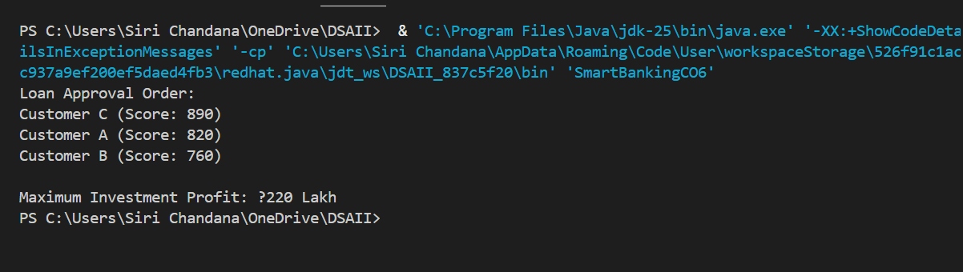

• High-credit-score customers are approved first.
• Investment budget is allocated optimally.
• Bank profit is maximized.
• Decision-making becomes faster and more accurate.
• Resources are utilized efficiently.
GitHub Link: https://github.com/ksirichandana007-cmyk/Smart-Banking-System.git

Student Signature | Faculty Signature

